**8-BIT MULTIPLICATION**  
  
  
**EXP NO: 3**

**AIM:** To write an assembly language program implement 8-bit multiplication using 8085 processor.  
  
  
**ALGORITHM:**  
  
  
1)      Start the program by loading a register pair with the address of memory location.  
2)      Move the data to a register.  
3)      Get the second data and load it into the accumulator.  
4)      Add the two register contents.  
5)      Increment the value of the carry.  
6)      Check whether the repeated addition is over.  
7)      Store the value of product and the carry in the memory location.  
8)      Halt.  
  
  
   
  
  
**PROGRAM:**  
  
  
  
  
  
      LDA 8500  
  
  
       MOV B, A  
  
  
       LDA 8501  
  
  
       MOV C, A  
  
  
       CPI 00  
  
  
       JZ LOOP  
  
  
       XRA A  
  
  
       LOOP1: ADD B  
  
  
       DCR C  
  
  
       JZ LOOP  
  
  
       JMP LOOP1  
  
  
       LOOP: STA 8502  
  
  
       RST   
1       
  
  
  
  
  
  
  
  
**INPUT:**

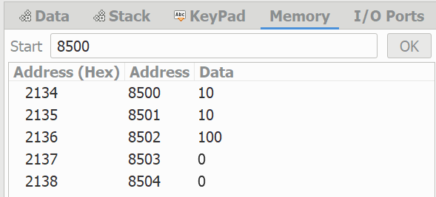  
  
  
  
  
  
  
  
  
**OUTPUT:**

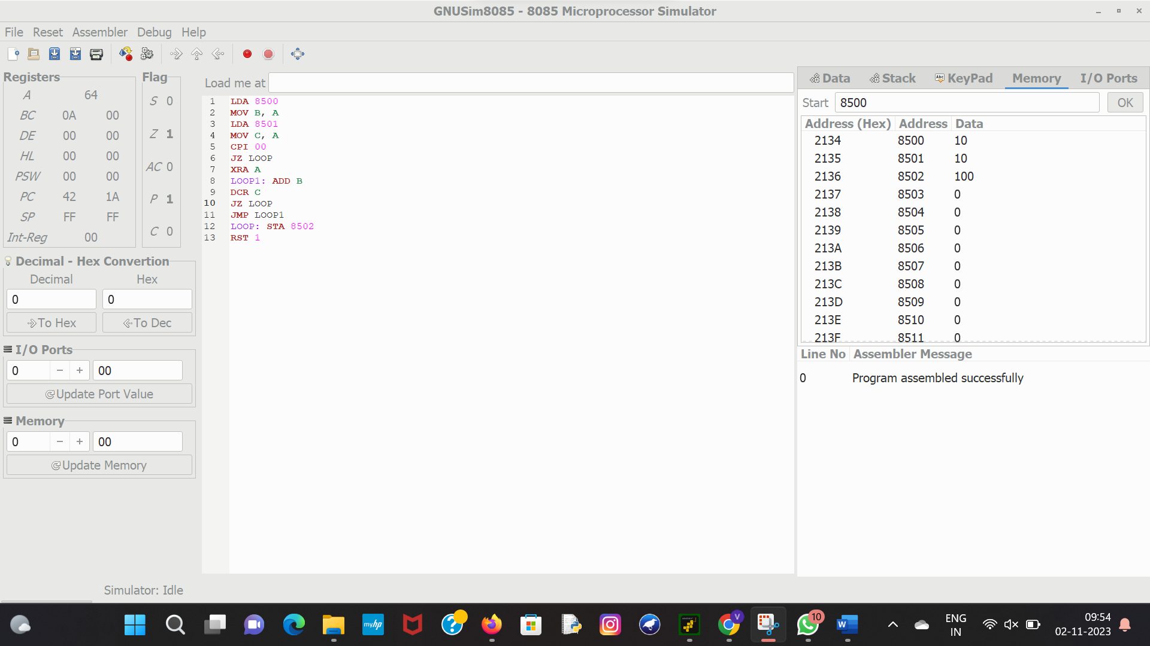  
  
  
   
  
  
   
  
  
**RESULT:** Thus the program was executed successfully using 8085 processor simulator.